PRD: FreshConnect Local

Spring 2026

List all students who actively worked on this PRD Report:
- Name: Shrividya Shashidhara
- Name: Rujuta Lad
- Name: Barath Keshav Sriram Kumaran
- Name: Priyanka Senthil Kumar
- Name: Santhosh Kumar Sudhandrakumar

Vision
Restaurants and food businesses throw away millions in edible surplus every day, while NGOs and community kitchens can't afford quality food. FreshConnect Local is a real-time B2B marketplace that turns one business's excess into another's opportunity, cutting food waste by up to 40% and putting meals on more tables by bringing together sellers, buyers and the community as a whole.

Motivation

Customer Segments
Segment 1: Food Providers - Restaurants, Cafés and Dining Operations
Demographics: Restaurant managers, chefs, and operations staff aged 25 to 55 running quick-service restaurants, ethnic eateries, bakeries, buffets, and university dining halls in urban areas. Our interviews covered operations across Greater Boston, including Fenway, Mission Hill, Cambridge, Dorchester, Somerville, and Quincy.
Key Behaviours: Generate 5 to 25% daily food waste, primarily driven by demand unpredictability, overproduction during peak hours, and strict food safety hold-time policies. Most discard surplus at closing with no redistribution system in place. Weekly surplus ranges from 5 kg at small cafés to 80 kg at university dining halls.
Attitudes: Open to redistribution if it requires zero additional labour. Motivated by cost recovery and reducing disposal fees rather than altruism alone. Skeptical of solutions that add operational complexity, especially during peak hours.
Early Adopters vs. Mainstream Users: Early adopters are independent restaurant owners and university dining supervisors already absorbing the financial pain of daily disposal costs. They are willing to trial a new platform if onboarding is frictionless and requires no additional staff effort, as demonstrated by Ashok (Mirchi Nation), Rajesh (Shanti Taste of India), and David (University Catering, Northeastern). Mainstream users include larger QSR chains and hotel catering operations and will require proven reliability, POS system integration, and regulatory compliance documentation before adoption.
Segment 2: Food Recipients - NGOs, Community Kitchens & Catering Services
Demographics: NGO coordinators, temple kitchen managers, community program staff, and catering operators aged 25–55 serving vulnerable populations or event-based clients on limited budgets. Interviews included organisations such as Immigrant Family Services Institute (IFSI), Boston Community Food Network, and small-scale community caterers.
Key Behaviours: Source food through food banks, wholesalers, and informal donations. Experience 2-3 supply shortages monthly. Actively seek affordable, quality food to stretch tight budgets and serve more people.
Attitudes: Eager to access surplus food but require food safety guarantees like temperature logs, holding time documentation, and allergen labelling as non-negotiables. Value reliability, consistency, and dignity in sourcing. Cannot build meal plans around uncertain supply.
Early Adopters vs. Mainstream Users: Early adopters are NGO coordinators and community kitchen managers already accustomed to informal, unpredictable sourcing and flexible enough to adapt pickup logistics for cost savings, as seen with Jessica (IFSI) and Lakshmi (Temple Community Kitchen). Mainstream buyers are corporate cafeterias and large catering firms and will need consistent supply volumes, certified food safety documentation, and seamless platform integration before committing.
Evidence and Research Design
To validate these hypotheses, the team conducted interviews and gathered insights from individuals within each segment. The research aimed to uncover pain points related to food waste, the desire for cost recovery, and the challenges of sourcing affordable surplus food reliably.
Research Details:
- Sample Size: 25+ participants
- Methodology: In-depth interviews and phone surveys
- Locations: Greater Boston (Fenway, Mission Hill, Cambridge, Dorchester, Somerville, Quincy, Watertown), Philadelphia, and Dallas

Key Questions Explored:
Q1: What are the primary sources of food waste in your operations?
Statistical Data:
- Overproduction/Demand Fluctuation: 35%
- Freshness Standards: 25%
- Buffet End-of-Service: 20%
- Order Errors/Cancellations: 12%
- Prep By-products: 8%
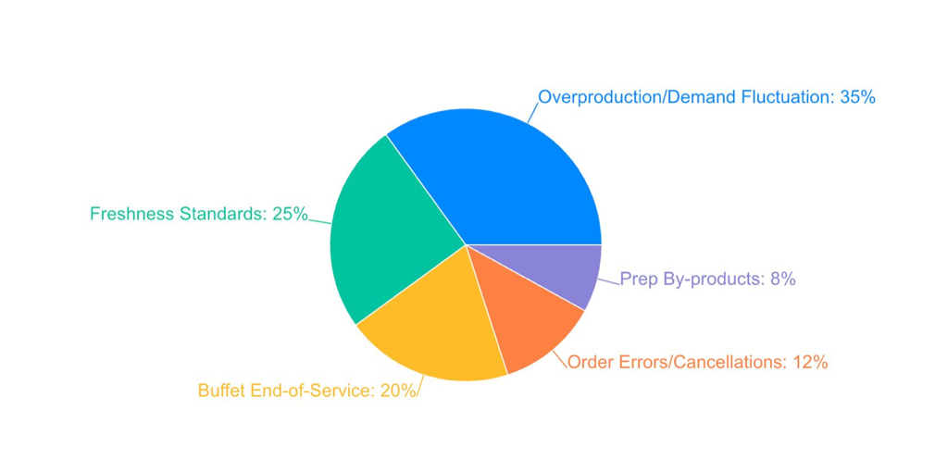
Fig 1. Pie chart illustrating the breakdown of waste sources across seller interviews

Q2: What concerns would you have about purchasing surplus food from restaurants?
Statistical Data:
- Food Safety & Temperature Control: 20 respondents
- Reliability of Supply: 16 respondents
- Timing/Pickup Logistics: 15 respondents
- Quality Documentation: 13 respondents
- Cultural Appropriateness: 6 respondents
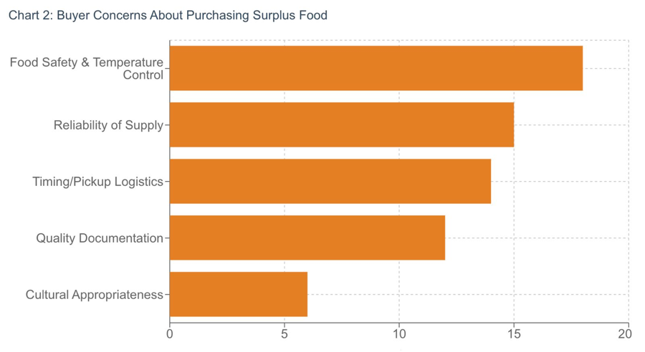
Fig 2. Bar chart showing the most cited barriers across buyer interviews.

Q3: Have you tried solutions to reduce waste or donate food? What worked and what didn't?
Statistical Data:
- Tried portion control/batch reduction with partial success: 60%
- Attempted donation but faced timing/logistics barriers: 55%
- No structured redistribution system in place: 30%
- Successfully maintained consistent redistribution: 5%
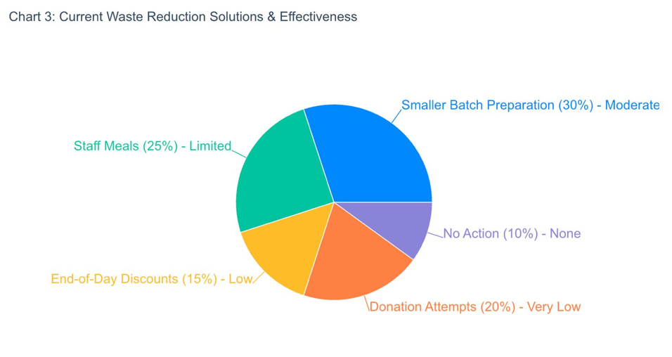
Fig 3. Pie chart depicting which solutions sellers have tried and their effectiveness

Key Findings:
- Food Providers consistently waste 5-25% of prepared food daily and are open to redistribution only if it requires no additional operational effort.
- Food Recipients face 2-3 supply shortages monthly and cannot build reliable meal plans around unpredictable surplus availability.
- The central barrier across both segments is the timing gap. Surplus is generated at 8-10 PM while most buyers need food by 5-7 PM, making cold storage and pre-scheduled pickups essential to any viable solution.

Verbal/Visual Walkthrough of Use Cases
Use Case 1:Persona: Samiksha- A College Student Buyer (Northeastern University)
Samiksha is a graduate student living near campus in Boston. She spends around $15 a day on lunch, which adds up fast on a student budget. She has no idea that restaurants two streets away are throwing away fresh food every afternoon.

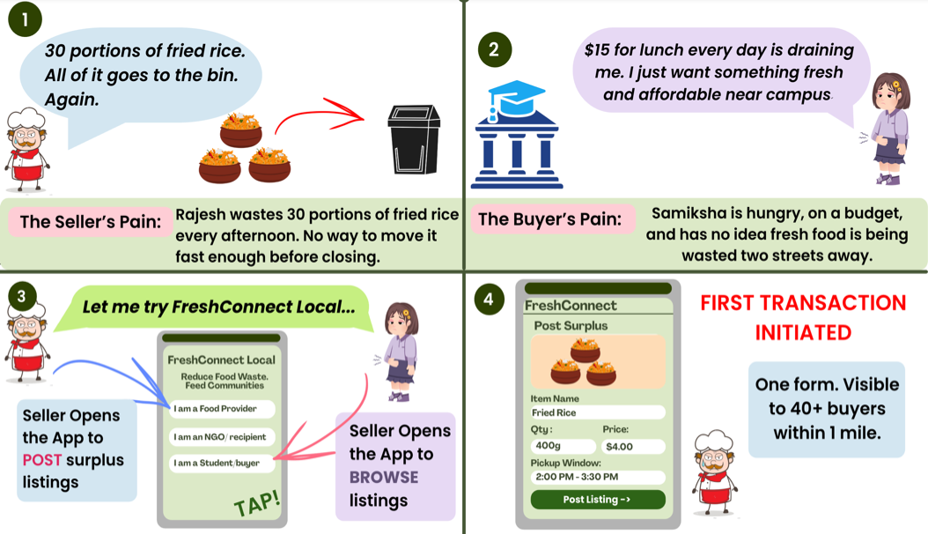
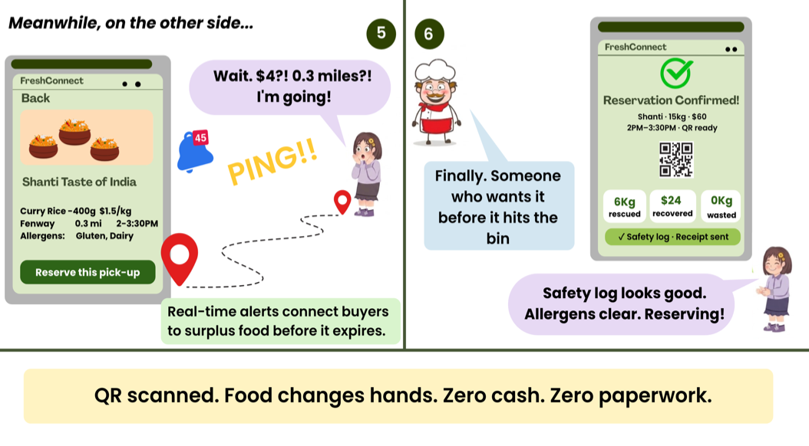
Fig 4: Visual Walkthrough of how FreshConnect Helps a Hungry Student
Use Case: Finding and Reserving Surplus Food
- At 1:55 PM, Samiksha gets a push notification on her phone: "Curry Rice available 0.3 miles away. $4, pickup by 3:30 PM." She taps it and lands on the listing page for Shanti Taste of India. She can see the item, quantity, price, how far it is, and the allergen information. Everything looks good, so she taps Reserve this pick-up.
- A QR code instantly appears on her screen and a receipt is sent to her email. She walks over, shows the QR code to the seller, collects the food, and that's it. No cash, no paperwork, done in under 5 minutes.
- She saved $11 compared to her usual lunch. The seller recovered $60 that would have gone in the bin.
Use Case 2: Persona- Melina the Caterer
Melina runs catering for corporate and campus events in Boston. She works on tight timelines and tighter budgets, and when a supplier falls through, she has nowhere to turn quickly. Food banks are too slow and platforms like Too Good To Go don't support bulk orders.
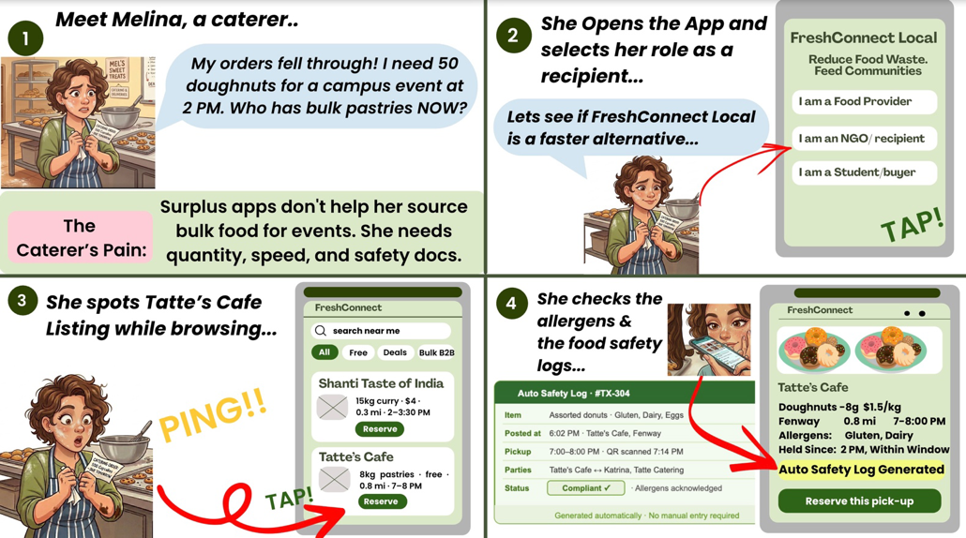
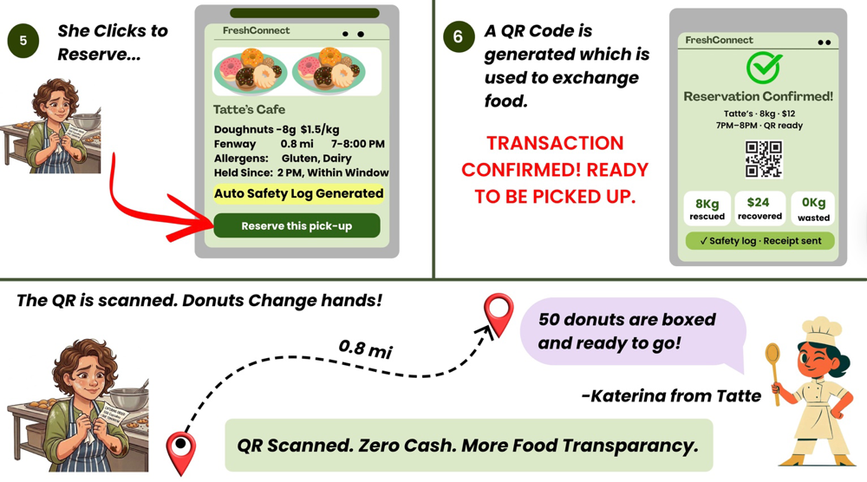
Fig 5.1 & 5.2: Visual Walkthrough of how FreshConnect Helps a Catering Service
Use Case: Finding Surplus Pastries for a Campus Event
- It's 10 AM. Melina has a corporate lunch on campus at 2 PM, and her bakery order has just been cancelled. She opens FreshConnect Local, selects the NGO/Recipient role, and switches on the Bulk B2B filter. Immediately, she sees Tatte's Café with 50 assorted doughnuts, free, 0.8 miles away, with a pickup window 7-8 PM.
- She taps the listing, checks the allergens (Gluten, Dairy, Eggs) and sees the auto-generated safety log is already there. She taps Reserve. A QR code appears on her screen, and a receipt lands in her inbox. She dispatches her driver, who shows the QR at the cafe. The doughnuts change hands. Zero cash. Zero paperwork.
- The campus event goes ahead. Tatte's Cafe rescued 50 doughnuts from the bin. Nobody had to make a single phone call.
Use Case 3: Finding Free Donations for an NGO- Persona: Jessica- IFSI Coordinator.
Jessica runs food programs for children at Immigrant Family Services Institute (IFSI) NGO. Every Christmas she tries to make sure every child gets a dessert at the holiday party. It's a small thing that means everything to the kids. This year the budget ran out on the main meal. Desserts weren't going to happen. She was out of options and out of time.
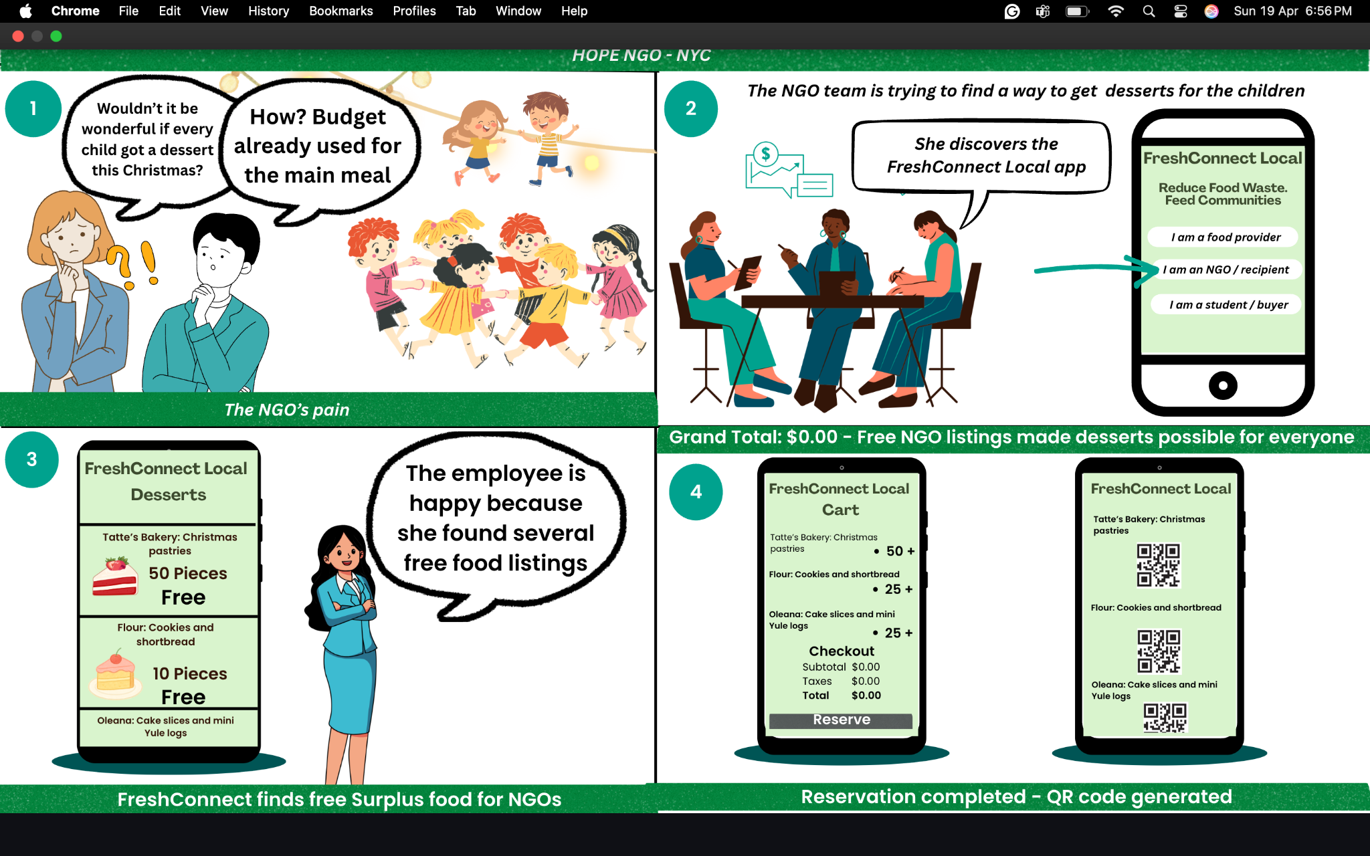
Fig 6: Walkthrough of How FreshConnect Would Operate for NGOS
Use Case 3.1: Finding Free Surplus Desserts for a Children's Christmas Party
A colleague mentions FreshConnect Local. Jessica downloads the app, selects "I am an NGO / recipient" and gets verified in under two minutes. She searches for desserts nearby and can't believe what she sees. Tatte's Bakery has 50 Christmas pastries listed for free. Flour has 10 cookies and shortbread. Oleana has cake slices and mini Yule logs. All free. All within reach. She adds everything to her cart. Grand total: $0.00.
She taps Reserve. Three QR codes land in her inbox, one per seller. Her volunteers pick up each order during the pickup windows. Every item comes with an auto-generated safety log so Jessica has the documentation her board requires, without filling out a single form herself. That Christmas, every child at the party got a dessert.
Use Case 4: From the Administrative Point of View:
Ashley is the person behind the curtain. While Rajesh is posting curry rice and Katrina is reserving donuts, Ashley is watching the whole city's food move in real time from her dashboard. She doesn't touch the food. She makes sure the platform that moves it never breaks down.
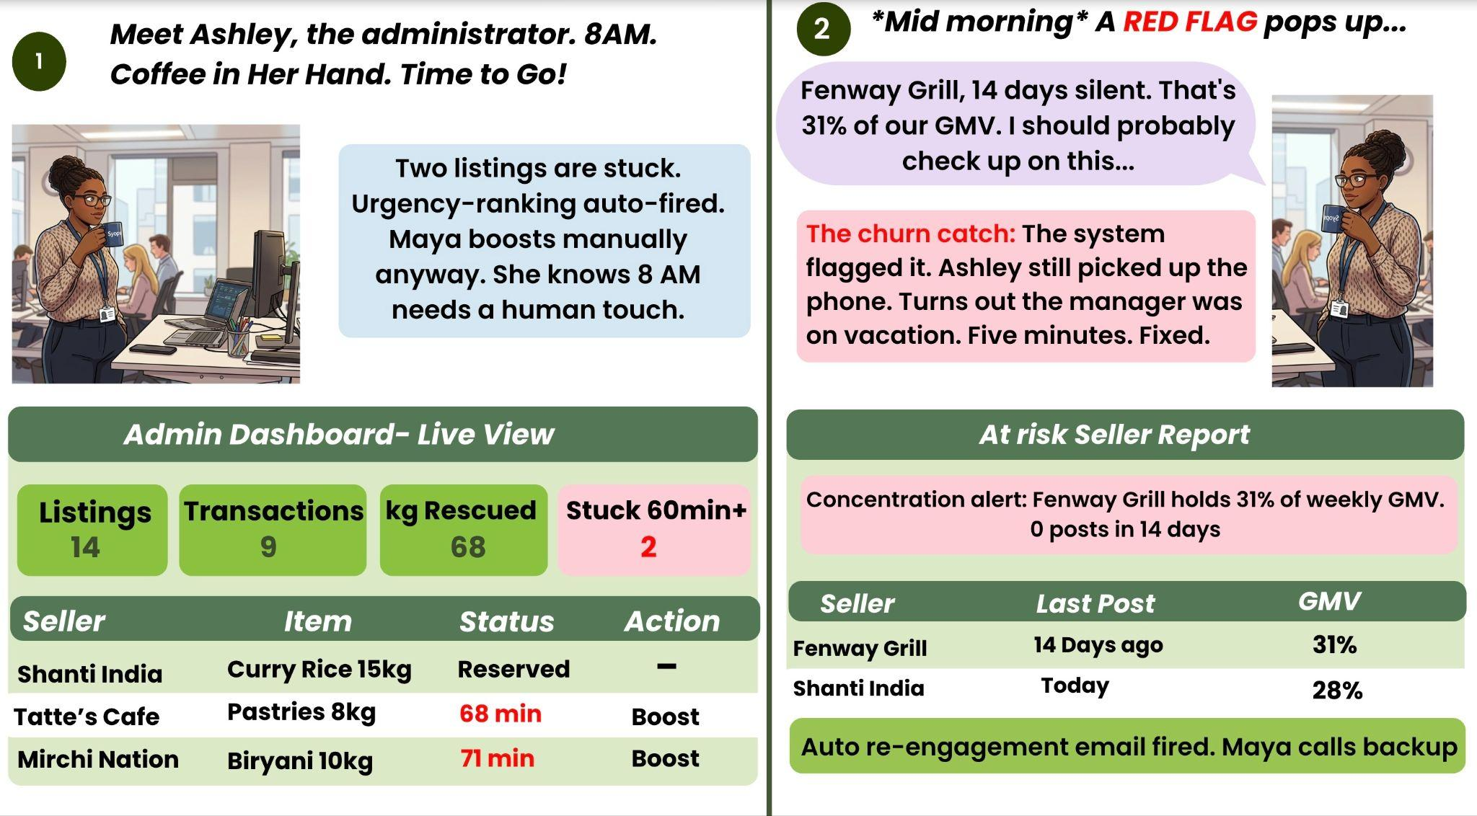
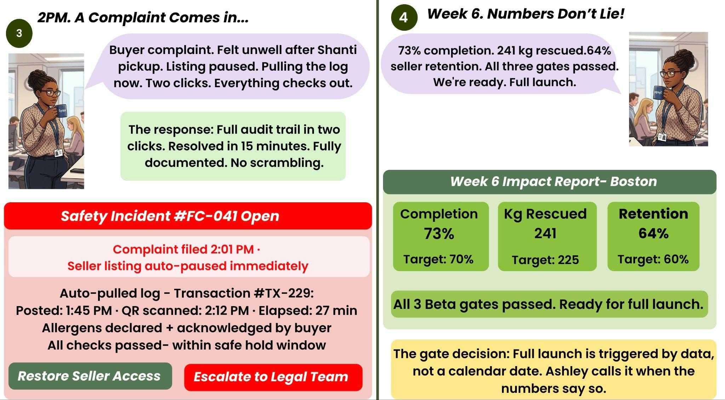
Fig 7: Visual Walkthrough of the Administrator Operator Behind the Curtains
Use Case 4.1: Morning Health Check
At 8 AM, Ashley opens the admin dashboard. Fourteen listings are live, nine transactions closed overnight, and 68 kg of food was rescued. But two listings have been sitting unclaimed for over 60 minutes. The platform already bumped them up in buyer feeds automatically. Ashley manually checks that both sellers are still open and their pickup windows are still valid. One quick fix, done before her coffee gets cold.
Use Case 4.2: Catching a Churn Risk
Mid-morning, a flag pops up. Fenway Grill hasn't posted in 14 days and they account for 31% of weekly GMV. The system fires an automated re-engagement email. Ashley picks up the phone anyway. Turns out the manager went on vacation and forgot to hand off the app. Five minutes later, Fenway Grill is back online. Crisis avoided before anyone noticed.
Use Case 4.3: Handling a Safety Complaint
At 2 PM a buyer files a complaint. They felt unwell after a pickup from Shanti Taste of India. Ashley pulls up Transaction #TX-229 in two clicks. The safety log is right there: posted at 1:45 PM, QR scanned at 2:12 PM, 27 minutes within the hold window, allergens declared and acknowledged by the buyer. Everything checks out. Seller is paused as a precaution, log sent to the legal team, buyer followed up with directly. Fifteen minutes, fully documented, no scrambling.
Use Case 4.4: Calling the Launch
Week 6. Completion rate: 73%. Kilograms rescued: 241. Seller retention: 64%. All three beta gates cleared. Maya types one line in Slack: "We're ready. Full launch."

Detailed Design & Features Description
Design Principles
Each and every design choice made for FreshConnect Local adheres to a single guiding principle: food goes bad. FreshConnect Local exists as a way to transport perishable food from seller to consumer within a set time period, and any and all design considerations are based around helping or hindering that process. The following principles form the backbone of product development.
Design for Speed, Not Features
The owner of an eatery who must shut down operations at nine o’clock sharp will be unwilling to go through an elaborate posting procedure for their inventory. Each additional field, page, or confirmation will make it easier to simply throw out the food than list it. The FreshConnect Local design prioritizes efficiency over features, with a maximum goal for creating listings under two minutes and reserving it under half a minute. Any addition not able to meet these benchmarks is rejected.

Documentation as a System Element, Not a User Initiative
For institutions to be able to purchase, it is a must that documentation exists for the sake of their board, funders, and for their protection from potential lawsuits. Asking vendors to prepare and submit documents after the sale is impossible to implement operationally. With FreshConnect Local, this dilemma will never happen because everything will be automated right within the transaction. Every time there is a creation of a listing, its reservation, and pick-up, the system automatically creates a food safety documentation record and an allergen list as well as the receipt.

Role-Based Product Approach
A business owner, a coordinator, and a student are three distinct people who would open the application for totally different purposes. Showing them a unified interface to adapt to the same environment is a mistake in product development. FreshConnect Local takes the approach of role-based design even from the very beginning of using the application. Each role will have its own interface to use based not on different data, but context-dependent behavior.

Simplicity Over Completeness at Launch
The MVP does not attempt to solve every edge case. There will be allergens that go undisclosed, pickup windows that don't align perfectly, and transactions that fail. The goal of the MVP is not to be perfect but to validate that the core loop (post, browse, reserve, pick up) creates enough value on both sides that people come back. Everything else is vNext.

Features/Information architecture
The following section walks through each major feature of FreshConnect Local in the order a user would use it, starting from opening the app for the first time and ending at a completed transaction.
Role Selection & Onboarding
The first page a new user will see is the role selection page, where there are three different roles presented to the user, namely: “I am a Food Provider,” “I am an NGO / Recipient,” and “I am a Student / Buyer.” This page is by far the most crucial page in the entire product, as the role selected will determine everything that follows, from their dashboard appearance to the action that is open to them, and even the notifications they receive and which listing they can view.

The onboarding process will take less than two minutes for users of all roles. The Food Provider has to provide their company name, their physical address, and a standard time frame of when they can provide delivery services. The NGO/Recipient will provide their organization’s name and their usual food volume requirements, while the Student/Buyer will only need to provide their name, email address, and current physical location.

There is also no such thing as a multi-page onboarding experience. Instead, each section is on its own single page, and the user will have access to a clear progress bar on every step.
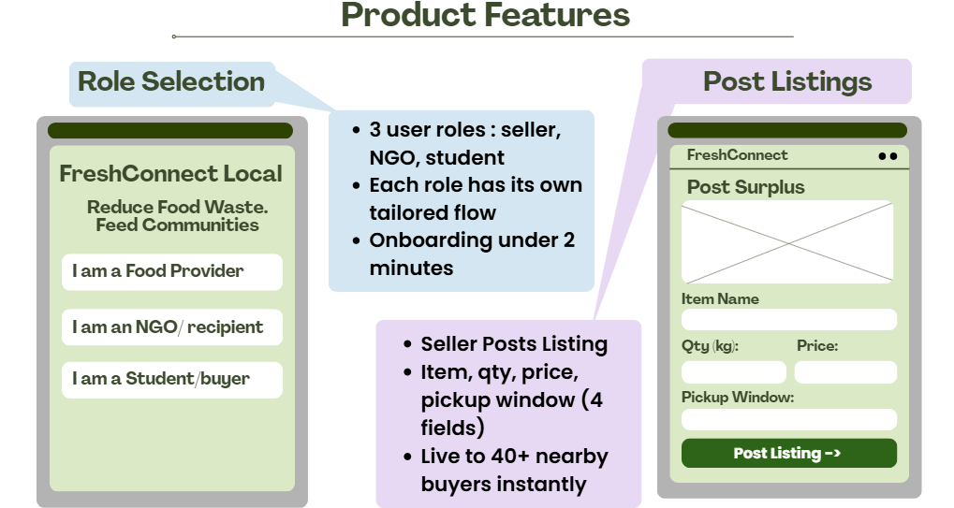
Fig 8: UI for Role selection and Post Listing Form
Seller: Posting a Surplus Listing
Posting a surplus listing is the single most operationally critical action on the platform. If sellers find it too slow or too complicated, they default to throwing the food away, which is exactly the behavior the product exists to prevent. The listing creation screen is built around four required fields presented on a single scroll:
- Item Name: Free text, maximum 50 characters. Sellers use their own language, no dropdown problem to wrestle with.
- Quantity: Numeric input with a kg/lbs toggle, accommodating both restaurant and grocery contexts.
- Price: Numeric input with a $0 option, enabling free listings for NGO-only donations without requiring a separate donation flow.
- Pickup Window: A time range picker pre-populated from the seller's default hours but editable per listing.

A fifth field allergen disclosure via a multi-select checklist of the 14 standard FDA allergens is present at MVP but optional. It becomes mandatory in v1.1 once the compliance layer is enforced. Sellers who fill it in at MVP receive a trust badge on their listing card.
Once the seller taps Post Listing, the listing goes live instantly. A push notification fires to all verified buyers within a 2–3 mile radius within 60 seconds. The seller sees a confirmation screen showing how many buyers were notified and a live counter of reservations as they come in. The whole flow from opening the app to seeing the confirmation screen is designed to take under two minutes.
Buyer: Browse & Reserve
The initial screen when a buyer logs into the app is a browse feed arranged by proximity not date or price. The most proximal available listing comes first. This is an intentional design decision because when dealing with surplus food redistribution, the critical factor is closeness. An item listed for sale 3 miles away with a 30-minute window would effectively be across town.
Each feed listing displays information including seller name, food item, amount available, price, distance, and a countdown clock indicating the time remaining before the listing expires. The countdown clock serves a dual purpose: firstly, it indicates the limitation of surplus food through the need for timely action without any additional text, and secondly, it adds just enough pressure for buyers to take action.

Upon tapping a listing, the buyer enters a detailed view where they can see allergen information, an automatically generated food safety log indicating temperature hold times at the time of posting, and a Reserve button. Upon clicking Reserve, the QR code is generated on the buyer’s device and a notification is sent to the seller that the item has been reserved. Payment is not taken until Reservation. It is settled at the pickup when the buyer scans the seller's QR code, which simultaneously timestamps the transaction and closes the safety log.
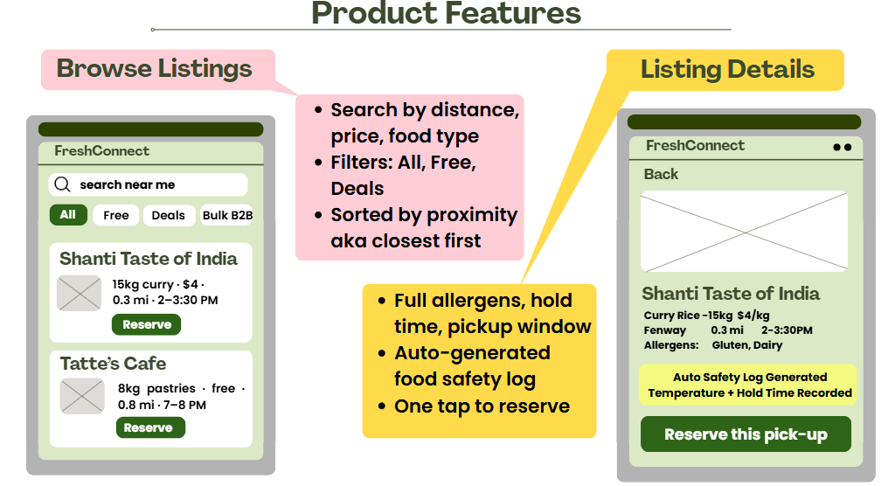
Fig 9: UI for Browsing Feed and Listing Details with Reserve Option
Auto-Generated Safety Log
The safety documentation system is invisible to the user, it runs in the background as a byproduct of the transaction, not as a separate compliance workflow. Here is what the system records at each stage:

- At listing creation: food item, quantity, seller ID, listing timestamp, and pickup window.
- At reservation: buyer ID, buyer organization type, and reservation timestamp.
- At QR scan / pickup: final transaction timestamp, quantity confirmed transferred, and price settled.

Within 60 seconds of the QR scan, both parties receive a PDF receipt containing all of the above, formatted as a food safety log. For NGO buyers, the document includes a Good Samaritan Act disclaimer formatted to meet the institutional record-keeping requirements their boards typically require. This auto-generation directly removes the compliance burden that prevented 80% of potential institutional buyers from participating in surplus procurement in our interviews.

NGO & Institutional Buyer Features
Institutional buyers see a modified browse interface with a minimum quantity filter as the primary control. An NGO sourcing food for 50 families does not want to scroll past listings for 400 grams of curry, they need to see bulk volume quickly. The filter lets them set a floor on quantity so that only operationally relevant listings are shown.

The NGO dashboard also shows a cumulative impact tracker: total food rescued in kilograms, total cost saved versus retail procurement, and number of meals enabled (calculated at 250 grams per meal). This is not a vanity metric, it directly supports the accountability reporting that NGO coordinators owe to their donors and boards. Seeing this data keeps institutional buyers engaged and gives them a concrete story to tell about the platform's value.
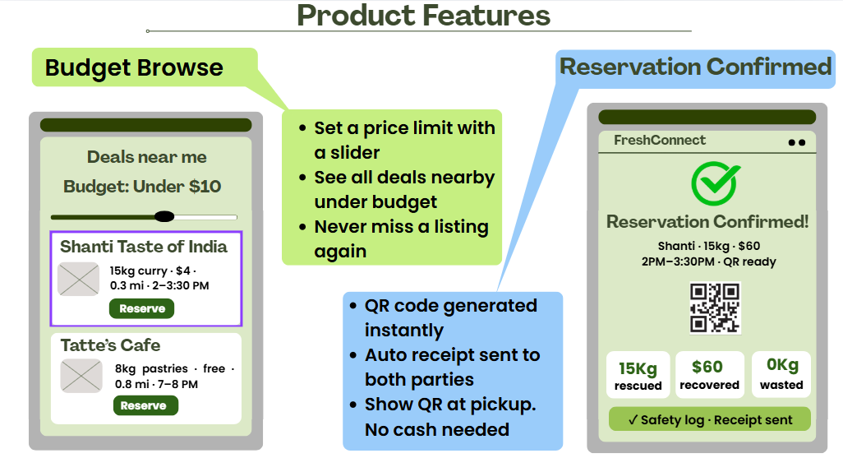
Fig 10: UI for Budget Browse Feature and Reservation Confirm Page
Features of the Student & Budget Buyer Interface
The main feature of the interface used by students is the ability to discover deals and prices. With a Budget Browse slider located at the top of the feed, the student can select an upper price limit, and then the feed will be updated instantly to display only those listings whose price does not exceed the selected level. There is also a separate tab called Deals Near Me that displays all free and discounted items within 0.5 miles depending on the time when the collection period ends.

Push notifications are aimed at delivering personalized information to the student audience and are triggered in cases where a new listing is posted within 0.5 miles at a price lower than the selected price ceiling by the student. Students have an opportunity to receive notifications in two different formats, All Deals or Best Deals Only, to reduce the number of alerts received while using the platform.

v1 aka Minimum Viable Product (MVP)
The MVP is scoped to the core transaction loop: Post, Browse, Reserve, Pickup. Every feature below is evaluated against a single question without this, can a transaction happen? If yes, it is P1 or later. If not, it is P0.

Priority | Feature | User Outcome | Launch Criterion
P0 | Role-based onboarding (Food Provider, NGO, Student) | User selects role, completes profile in < 2 min | 100% onboard without support contact
P0 | 4-field listing creation with instant publish | Seller live to buyers within 60 sec of posting | Listing-to-notification latency < 60 sec
P0 | Proximity-sorted browse feed with countdown timers | Buyer sees closest listings with time remaining | Feed loads in < 2 sec on 4G
P0 | One-tap Reserve with QR code generation | QR generated, seller notified within 5 sec of tap | QR delivery < 5 sec
P0 | Auto-generated safety log on QR scan | Both parties receive PDF receipt within 60 sec | 100% of completed transactions logged
P1 | Budget Browse price slider | Students filter by price ceiling in real time | Filter response < 500 ms
P1 | Push notifications with 2–3 mile geofence | Buyer alerted to new nearby listings immediately | Delivery rate > 95%
P2 | Seller impact dashboard (kg rescued, $ recovered) | Seller sees cumulative impact metrics | Dashboard viewed weekly by > 60% of sellers
P2 | NGO bulk quantity filter | Institutional buyers filter by minimum quantity | NGO reservation rate improves 20% vs unfiltered

Table 1: MVP Feature Priority Matrix

vNext
Features for Students and Budget Buyers
The student dashboard focuses on deal finding and price visibility. The following features have been deemed valid based on our research; however, their implementation has been deferred to MVP in order to maintain launch focus and prioritization.

- Rotating Listings: The seller sets up automatic recurring listings depending on past experiences of excess supply; e.g., each weekday at 8 PM, 15 kg curry. This is the single most frequently reported problem in our seller interviews, and likely the reason for premature churn post-onboarding.
- Allergen Compliance (Required): Disclosing allergens is made mandatory, and buyers are provided with options for filtering out listings with allergens incompatible with their dietary needs. The option for disclosing allergens is present in MVP; enforcement and filtering come next.
- Seller Ratings & Trust Seals: Post-transaction ratings are provided by the buyer on pickup. Sellers build trust through their reputation (e.g., Verified Seller, Completed More Than 5 Transactions, Food Safety Certified); displayed on listings. Trust signals make buyers more comfortable buying from unknown sellers.
- NGO Repetitive Issues: Institutional customers commit to purchasing a fixed amount of an item from a particular seller at a predetermined price level. This ensures demand visibility for sellers, who have more control than any other mechanism available.
- In-Application Transaction Communication: Instant communication between the buyer and the seller, limited only to the transaction taking place, no generic social networking capabilities. Deals with exceptions such as early delivery, quantity changes, and late pick-up situations.

vLongterm
- POS Integration for Toast and Square: Seamless integration with the POS systems to automatically detect closing inventory and pre-fill surplus postings, bringing the seller's posting time down from two minutes to negligible.
- Dining Hall Onboarding and Bulk Management: An onboarding process and dashboard designed exclusively for institutional sellers such as university dining halls, who produce between 60-80 kg of surplus per week and offer some of the most reliable suppliers on our platform.
- Sustainability Dashboard: Impact reports in ESG format for corporate and institutional sellers, allowing them to measure food waste and track their progress towards their sustainability goals.
- Multi-City Expansion with Compliance Management: A compliance system that automates the process of applying the correct documentation requirements for food redistribution according to the city in which the seller is located.

Roadmap / Timing
FreshConnect Local rolls out across four quarters, each anchored to a single primary objective: Acquisition in Q1, Activation in Q2, Retention in Q3, and Expansion in Q4. Features are released to serve the objective of the quarter they fall in, not to demonstrate breadth. The roadmap is designed around one firm principle. We do not pursue scale before we have proven retention, and we do not enforce compliance before we have proven adoption.

The entire Year 1 roadmap operates within an estimated budget of $119K, scaling with grant funding and university partnership offsets. Competitive urgency is moderate at the local level. No existing platform currently operates a B2B surplus redistribution model in Boston, but increases if we delay seller relationship-building past Q2.

Q1: Foundation & Closed Alpha (Months 1-3)
The goal of Q1 is acquisition: get the first 25 sellers and 40 buyers onto the platform and close 50 real transactions. Everything in Q1 is hand-held. Sellers are recruited directly by the team through the restaurant contacts built during our 25 interviews with Mirchi Nation, Shanti Taste of India, Northeastern dining staff. Buyers are recruited from Northeastern University student organizations and two NGO contacts with pre-existing relationships (Immigrant Family Services Institute and Boston Community Food Network).
Transactions in Q1 are monitored in real time by at least one team member available on-call. Every failed transaction is treated as a product bug, not a user error. The alpha concludes when 50 completed transactions are on record with zero critical food safety incidents.
Initiative | Description | Priority
MVP build complete | Core transaction loop live: post, browse, reserve, QR pickup, safety log | High
Closed alpha cohort recruitment | Hand-recruit 10 sellers and 15 buyers from Boston restaurant and university contacts | High
50 completed transactions | Monitor all transactions in real time; treat every failure as a product bug | High
Internal demo to course stakeholders | Present working product with real transaction data from alpha cohort | High
Waitlist & sign-up campaign | Landing page with email collection ahead of Q2 open beta | Medium
Table 2: Q1 Closed Alpha Initiatives and Priorities
Why closed alpha and not an open soft launch? Marketplace cold-start problems are best solved through controlled seeding, not open acquisition. An empty browse feed on day one drives immediate buyer churn that is very difficult to recover from. The alpha gives us real transactions and real impact data before any user signs up without being personally invited.

Q2: Open Beta & Activation (Months 4-6)

Q2 opens registration to any Boston-area food business and any qualified buyer organization. The objective shifts from simply getting users on the platform to ensuring they actually complete transactions. A 70% transaction completion rate, 7 out of every 10 listings get claimed, is the primary success criterion for this quarter. Below 60%, sellers abandon the platform because they feel their surplus is not worth the effort of posting.

Seller acquisition in Q2 is driven by campus outreach at Northeastern and BU, outreach through the Boston Food Network partnership, and social content showcasing Q1 impact, kilograms rescued, transactions completed, and money recovered. These numbers matter because they are the social proof that moves skeptical restaurant operators who need to see that other sellers are actually using it before they will try it themselves.

Initiative | Description | Priority
Open registration (Boston metro) | Invite waitlist, expand to any qualifying food business or buyer organization | High
Campus outreach at Northeastern & BU | Tabling, flyers, student org partnerships to drive buyer acquisition | High
Boston Food Network partnership activation | Formalize NGO buyer onboarding through existing food network relationships | High
Push notification & Budget Browse launch | Release P1 features: geofenced alerts and student price-ceiling filter | High
500 lbs / month food rescued | 25 sellers × 5–8 kg × 2 posts/week, validated against Q1 interview data as a conservative floor | Medium
Seller impact dashboard launch | Give sellers visibility into kg rescued and $ recovered to reinforce continued participation | Medium

Table 3: Q2 Open Beta Initiatives and Priorities

One potential risk associated with Q2 is that the self-serve onboarding process would lag behind the guided alpha onboarding process. Risk Mitigation Strategy: Tips and instructions provided within the application, two-minute walkthrough video integrated into the application, and WhatsApp contacts available during office hours. The second level of defense comes when the rate of self-service onboarding falls below 70%, and a 15-minute call needs to be made with the seller.
Q3: Retention & Stickiness (months 7- 9)

This quarter marks our most operationally critical quarter, because in a two-sided marketplace, retention becomes the most critical KPI. Without sellers coming back, the supply becomes unreliable. Without buyers coming back, the demand becomes unreliable. And the users of neither side of the marketplace can tolerate a platform where one of the key components becomes unreliable.

The benchmark for 60% seller retention, meaning that those sellers come back within 14 days after their previous list disappears, comes from the industry average in the early-stage food marketplace sector. A level below that would render the cost of acquiring more sellers higher than the growth rate. Hence, the highest focus heading into Q4 will be on seller retention.

Initiative | Description | Priority
Recurring listings launch | Sellers configure auto-repeat listings based on historical surplus patterns | High
Allergen enforcement (mandatory) | Allergen disclosure moves from optional to required; buyer filtering enabled | High
NGO recurring reservations pilot | 3 anchor NGO organizations subscribe to specific sellers at pre-negotiated volume and price | High
Seller ratings & trust badges | Buyers rate transactions post-pickup; sellers earn trust signals shown on listing cards | Medium
In-app transaction messaging | Lightweight buyer-seller messaging scoped to active transactions only | Medium
Table 4: Q3 Retention Initiatives and Priorities
Q4: Expansion (Months 10–12)

Full expansion is triggered by Q3 retention metrics. If seller retention is at 60% and buyer repeat rate is at 50%, Q4 proceeds with geographic and segment expansion. If either threshold is missed, Q4 is reoriented toward retention intervention before expansion is pursued. Expanding into a second market with a leaky first-market funnel is the fastest way to waste the budget and obscure which problem actually needs solving.
Geographic expansion targets Cambridge and Somerville as the natural adjacent market before considering a second distinct metro. Contiguous market extension preserves operational concentration, allows the same restaurant and NGO partnerships to stretch across a slightly wider geography, and keeps food safety oversight manageable. Entry into Philadelphia or Dallas is evaluated at the end of Q4 based on Q3 data and available partnership infrastructure in those cities.

Initiative | Description | Priority
Second market expansion (Cambridge / Somerville) | Extend Boston operations into contiguous metro; evaluate distant second city at Q4 end | High
University dining hall module beta | Dedicated onboarding and bulk dashboard for dining halls; target Northeastern and BU dining as first partners | High
Toast & Square POS integration (beta) | Auto-detect closing inventory and pre-populate surplus listings to reduce seller effort to near-zero | Medium
Sustainability impact dashboard | ESG-formatted reporting for corporate and institutional sellers feeding into annual disclosures | Medium
Year-end performance review | Compile full year metrics across all markets. Document what worked and what did not for future city launch playbook | Low

Table 5: Q3 Expansion Initiatives and Priorities

Scenarios for Service Introduction
The rollout of FreshConnect Local is structured around three different population introductions: closed alpha, open beta, and full launch. Each phase is decided by data, and each introduces the platform to a new population only after the previous one has been validated.
Alpha: Closed, Hand-Recruited Cohort (Q1)
The alpha population is assembled entirely through direct outreach from the team using the restaurant and NGO contacts built during the 25-interview research phase. Sellers are recruited individually from Mirchi Nation, Shanti Taste of India, and Northeastern University dining operations. Buyers are drawn from Northeastern student organizations and two NGO partners with pre-existing relationships, Immigrant Family Services Institute and Boston Community Food Network.
The alternative considered was a soft public launch with open registration from day one. It was rejected because a marketplace with an empty browse feed on launch day drives immediate buyer churn that is very difficult to recover from. A buyer who opens the app, sees nothing nearby, and closes it is unlikely to return. The closed alpha solves the cold-start problem by ensuring that when any buyer opens the app during Q1, food is already listed near them. The alpha concludes when 50 completed transactions are on record with zero critical safety incidents, not when a fixed date arrives.
Beta: Open Registration, Boston Metro (Q2)
Beta is the first time any user can sign up without a personal invitation. The population expands to any qualifying Boston-area food business or buyer organization, with geographic scope still restricted to the Boston metro to maintain supply and demand density.
Two alternatives were considered. The first was a campus-only beta, restricted to university dining halls on the seller side and students on the buyer side. This was rejected because concentrating both sides of the market within a single institution creates a dependency on one seller relationship and does not validate the multi-segment model the platform is built around. The second was skipping beta entirely and proceeding directly to full public launch after alpha. This was rejected because self-serve onboarding has not yet been tested. Alpha onboarding was guided by the team. Beta is the first real test of whether sellers can get themselves onto the platform without assistance, and that needs to be confirmed before the platform scales.
The gate from beta into full launch is not a date. It is three metrics: 70% transaction completion rate, 60% seller retention, and 500 lbs of food rescued per month. If all three are met, full launch proceeds. If any one lags, the following quarter is redirected toward fixing that specific problem before expansion is attempted.
Full Launch: Retention-Gated Expansion (Q3–Q4)
Full launch introduces the platform to two new populations in sequence. Geographic expansion into Cambridge and Somerville comes first in Q3 once retention thresholds are confirmed. The university dining hall module follows in Q4 once the expanded market has stabilized.
The alternative considered for geographic expansion was entering a distant second metro such as Philadelphia or Dallas ahead of Cambridge. This was rejected because contiguous market extension allows the same restaurant and NGO partnerships to stretch across a slightly wider geography without rebuilding the seller network from scratch. A distant metro entry would require restarting the cold-start problem in a city where the team has no existing contacts, no interview data, and no institutional relationships, while simultaneously trying to retain the Boston base. The operational cost of that distraction outweighs any first-mover advantage at this stage of the platform's development.
The sequencing logic across all three phases is consistent: the platform is not introduced to a new population until the previous one is retained. Expansion follows proof, not ambition.

Key Timing Sensitivities
- Competitor window: Too Good To Go introduced an API for businesses in late 2024. This pivot to a B2B redistribution strategy in the U.S. reduces our points of differentiation. The safety documentation layer and free-of-charge NGO access are the two attributes that will withstand competition pressure – provided we can build institutional relationships to validate them.
- University calendar dependency: Our densest target audience (college students) is active between September and April. An alpha launch in Q1 during the spring semester capitalizes on our most desired student demographic. A shift towards fall alpha bypasses the first organic acquisition phase.
- Government policy timeline: Massachusetts legislation governing food redistribution is currently static. All modifications to the state-level implementation of the Good Samaritan Act must undergo legal scrutiny prior to our Q3 allergen enforcement deadline. The latter could be delayed by 4 to 6 weeks.
- Funding opportunity windows: There are two key grants with application deadlines in Q1 and Q3 respectively (USDA SBIR, EPA Food Recovery Challenge). Application timing must be synchronized with milestones documentation to ensure the information is accurate and not merely projected.

Metrics
FreshConnect Local tracks success across three layers: impact metrics that reflect mission progress, operational metrics that indicate platform health, and traffic and engagement metrics that surface early warning signals before they affect top-line numbers.
- Impact Metrics: Food Rescued (225 kg/month) is the primary mission metric. It is derived from 25 active sellers posting twice a week with an average surplus of 5–8 kg per listing, validated through 25 in-person Boston restaurant interviews. The monthly target of 225 kg (approximately 500 lbs) represents a conservative floor, not an aspirational ceiling.
Food Rescued = Total kg Listed × Completion Rate
- Operational Metrics: Transaction Completion Rate (70%) measures the percentage of posted listings that result in a successful pickup. The 70% threshold is derived from seller behavior observed during interviews below 60%, sellers begin abandoning the platform because unclaimed listings feel like wasted effort. Since supply is the harder side of a two-sided marketplace to build and sustain, this metric functions as the platform's primary viability signal.
Completion Rate = Completed Pickups / Total Listings Posted
- Seller Retention (60%) tracks whether sellers return to post again within a 14-day window. Without consistent seller participation there is no supply, and without supply buyer engagement collapses. A 60% weekly retention rate is treated as the minimum viable threshold for sustainable platform operation.
Seller Retention = Sellers active in week N+1 who posted in week N / Total sellers active in week N
- No-Show Rate measures reservations where a buyer confirmed pickup but never scanned the QR code within the pickup window. This is the most damaging failure mode for seller trust, since the seller held food in anticipation of a pickup that did not happen. A target of under 10% is set for the MVP phase.
No-Show Rate = Reservations with no corresponding QR scan / Total Reservations
- Listing Expiry Rate tracks the percentage of listings that reach the end of their pickup window with zero reservations. This is essentially the platform's own waste metric if listings are consistently expiring unclaimed, the platform is digitizing the waste rather than eliminating it. A threshold of under 20% is set for Q1.
Traffic and Engagement Metrics:
These signals operate below the top-line numbers and are designed to surface problems early, before they register in operational metrics.
Zero Results Rate measures the percentage of buyer browse sessions that return no active listings. A high zero results rate in a given geography indicates either insufficient supply density or a radius constraint that is too tight. This is logged at the session level with location context to identify underserved zones.
View-to-Reserve Rate is the platform equivalent of a long click in traditional search quality frameworks. It measures the percentage of buyers who open a listing detail page and proceed to reserve. A low view-to-reserve rate signals a conversion breakdown buyers are browsing but not pickup windows that do not align with buyer availability.
Time to First Listing measures how long after onboarding a seller posts their first listing. The product commits to a two-minute posting flow, and this metric validates that commitment in practice. A median time-to-first-post exceeding 24 hours signals onboarding friction that will suppress supply before the platform reaches scale.
Push Notification Open Rate tracks the percentage of buyers who open real-time alerts when a nearby listing goes live. Since the notification is the primary discovery mechanism for time-sensitive listings, a low open rate directly predicts poor completion rate and is treated as a leading indicator requiring immediate investigation.
Transaction completion rate functions as the central health indicator across all layers. When it is healthy, most downstream metrics tend to follow. When it begins to decline, the traffic and engagement metrics, specifically zero results rate, notification open rate, and listing expiry rate allow the team to isolate whether the problem originates on the supply side, the demand side, or within the matching layer itself.
International
FreshConnect Local is not built for international markets yet, and that is intentional. We are a hyperlocal product because our entire model depends on sellers and buyers existing within 2-3 miles of each other. Spreading across geographies before Boston is proven would dilute the liquidity that makes this app work in the marketplace in the first place. That said, the global case for this product is real. The global surplus food market was valued at $56.8 billion in 2024 and is projected to reach $89.14 billion by 2030, driven significantly by the rise of mobile apps and platforms facilitating real-time surplus food recovery. We are building into a growing global wave, not a niche.

When will international versions be available?
Our sequencing is as follows:
- Year 1: Prove Boston, expand to 2 US cities by Q4.
- Year 2: Evaluate Canada (Toronto, Vancouver) as the first international pilot. Regulatory proximity to the US, English-speaking operator base, having a similar restaurant density and food waste profile to make it the lowest-friction entry point.
- Year 3: Consider Australia or the UK, where the B2B surplus model has already shown real-world traction. Yume, an Australian B2B surplus food marketplace, has demonstrated that commercialising surplus food at scale and connecting it with businesses and charities is operationally viable, which gives us a working proof of concept to learn from before we enter that market.

Tricky issues specific to FreshConnect Local:
- Food safety documentation: Our auto-generated safety log is currently designed around Massachusetts DPH requirements and the US federal Good Samaritan Food Donation Act. Every new country requires a full compliance audit. Europe's regulatory framework includes outright bans on food waste in countries like France and Italy, which actually creates a stronger mandate for our product, but the documentation standards we'd need to meet are more prescriptive than in the US.
- Cultural framing: In some markets, purchasing a restaurant's surplus carries stigma that simply doesn't exist in the Boston student and NGO context. The product positioning, buyer-side messaging, and even the name may need to change market by market. This is a go-to-market problem, not a technology problem and it's easy to underestimate.
- The B2B model doesn't translate automatically: Technology alone is insufficient for food recovery because the business models must be aligned with the sustainability concept across environmental, economic, and social dimensions. What works in Boston is where restaurants are motivated by disposal cost savings and NGOs are motivated by budget pressure. This may not be the right motivational frame in a market with different economics.
- Payment infrastructure: The platform runs on US payment rails today. India would need UPI integration. Europe would need SEPA. Each new market is a separate payments project on top of everything else.

What we're doing now to prepare:
We are not waiting until Year 3 to start thinking about this. A few small decisions we are making today will save us a lot of pain later.
- Language: The first is language. We are externalising all strings in the codebase from day one. No piece of text is hardcoded into the product. It sounds like a small technical choice, but it means that when we are ready to launch in Toronto or London, we are not ripping apart the app to translate it. The groundwork is already laid.
- Safety log: Right now it is built around Massachusetts and federal US requirements. But we designed it to be updated centrally so when we enter a new market with different food safety rules, the log adapts on our end. Sellers and buyers never notice. They just keep doing what they do.
- Watching Before Building: We are watching Yume closely. Yume has shown that a B2B surplus food marketplace connecting businesses and charities can operate at scale in Australia, a market with a completely different regulatory and cultural context than the US. There is a lot to learn from how they handled supplier onboarding, compliance, and buyer trust before we attempt anything similar ourselves.

We are not building for the world yet. But we are not building something that can only ever work in one city either.

Projected Costs
FreshConnect Local's MVP requires an estimated 18-22 engineer-months total across 6 months build-to-launch cycle. The table below outlines the roles, headcount, duration, and resulting engineer-months totals. The blended contractor/freelance rate is approximately $2,000-2,500 per engineer-month, consistent with early-stage MVP development using offshore or part-time talent.
Role | Headcount | Duration | Engineer-Months
Mobile App Developer (Android/iOS) | 1 | 5 months | 5
Backend Engineer (API, Matching Engine) | 1 | 5 months | 5
Full Stack Engineer (safety log, QR, listings) | 1 | 4 months | 4
DevOps / Cloud Engineer (part-time) | 1 | 3 months | 3
QA/ Testing Engineer (part-time) | 1 | 2 months | 2
Total | ~ 19 Engineer Months

Table 6: Engineering Headcount and Effort Estimates for MVP build

Development Phases:

- Phase 1 (Months 1-2): Core infrastructure, cloud setup, user authentication, role-based onboarding (seller, NGO, student), basic listing post, and browse functionality.
- Phase 2 (Months 3-4): Matching engine, real-time push notifications, QR code generation, safety log auto-generation, and reservation and confirmation flow.
- Phase 3 (Months 5-6): Testing, bug fixes, allergen and food safety documentation integration, soft launch to pilot users, and performance tuning.

Infrastructure & Machine Requirements
FreshConnect Local is a cloud-native application. No physical servers are purchased; all infrastructure runs on a managed cloud provider (AWS or Google Cloud), keeping costs variable and scalable. Estimated monthly cloud cost is $300-$600/month during the MVP phase, included within the $47K technology budget.

Component | Service Type | Purpose
App Server | 2x cloud compute instances (t3.medium) | Handles API requests, listing posts and reservations
Matching Engine | 1x compute instance with geospatial support | Real time proximity matching within 2-3 mile radius
Database | 1x managed postgreSQL (RDS) | Stores users, listings, transactions, safety logs
Push Notifications | Firebase Cloud Messaging | Instant buyer alerts when listing goes live
Cloud Storage | S3 equivalent Blob Storage | Stores safety logs, receipts and QR assets
CDN (Content Delivery Network) | CloudFront or equivalent | Fast content delivery for app assets
Staging Environment | 1x lightweight compute instance | Testing and QA before production deploys

Table 7: Cloud Infrastructure Components and their Purpose

Operational Needs

FreshConnect Local requires operational support across several functional areas, involving a mix of internal team roles, external contractors, and institutional partnerships. The nature of each commitment varies depending on the phase of the project.
- Technology Support will rely primarily on contracted developers during the MVP build phase covering mobile app development, the real-time matching engine, and cloud infrastructure setup. This is largely a finite commitment tied to the Q1 launch timeline. However, ongoing cloud hosting, bug fixes, and feature updates will require either a retained developer or a part-time technical resource post-launch, making the infrastructure maintenance component a continuous operational cost.
- User Support is an ongoing commitment. The team has identified two support representatives responsible for onboarding sellers and troubleshooting buyer-side issues. Given that the platform targets non-technical users, restaurant owners, NGO staff, and students, responsive user support is critical in the early stages to prevent churn. As the platform scales, this function will need to grow proportionally.
- Community and Outreach Roles include a dedicated outreach staff member for seller acquisition and a social media manager for buyer-side growth. These are ongoing roles throughout the year, with intensity expected to peak around Q1 and Q3 when new cities and segments are being onboarded.
- Sourcer and Partnership Coordination involves working with institutional partners universities, the Boston Food Network, and POS providers Toast and Square. Coordinating these relationships requires a project manager who can maintain communication and ensure integration timelines are met. The university and food network partnerships are ongoing, while the Toast and Square POS integration is a finite, milestone-based commitment targeted for Q4.
- Legal and Compliance Assistance will require contracted legal counsel for initial Good Samaritan Act documentation, food safety compliance filings, and Terms of Service drafting. This is largely a finite engagement during the pre-launch and launch period, though periodic reviews may be needed as the platform expands to new cities and regulatory environments.
Overall, the core operational commitments user support, community management, and cloud infrastructure are ongoing, while legal, app development, and POS integration represent finite, phase-specific engagements that are expected to conclude within the first operating year.

Addressing Caveats/Risks
Category | Risks | Mitigation
Health and Safety | Food Safety Liability:  FreshConnect could be held responsible if a buyer becomes ill from food surplus purchased on the platform, even when the restaurant is a direct source. B2B scale amplifies both exposure and traceability demands. | Every transaction auto-generates a safety log capturing time, temperature logs, allergens and platform coverage under the federal Good Samaritan Act. Legal paperwork filed in Massachusetts at launch. Audit trail provides defensible evidence in any liability claim.
Business | Low and inconsistent Donor Participation:  Classic cold- start problem for a two-sided marketplace. Sellers may not show up reliably starving buyers of supply and triggering platform abandonment. Inconsistency is as damaging as low volume. | 25 Boston sellers hand-onboarded by outreach staff before launch.Recurring listing templates and automated daily nudges lower friction for posting. Donor base diversified from Day 1 across restaurants, bakeries and cafes to reduce single category dependency.
Technology | Real Time Matching Failure at Peak Hours:  The matching engine must sustain performance during lunch and dinner surges, when listings and buyer requests spike simultaneously. Degraded performance at peak times erodes user trust at the worst possible moment. | Time-decay algorithm with urgency ranking surfaces expiring listings first. Auto-scaling cloud infrastructure adds capacity dynamically under load. A fallback queue ensures no listing is silently dropped during high-traffic windows.
Business | Anchor Donor Dependency:  If a small number of sellers account for the majority of listings, their departure could cause a sharp supply collapse, with little warning and limited short-term recovery options. | Concentration monitoring flags any single seller exceeding 30% of weekly supply, triggering a targeted diversification process. Platform maintains supplier variety across at least three food business categories from Q1 through Q2 as a structural safeguard.
Technology | Data Breach:  The platform stores sensitive transaction data, pricing, and buyer information, making it a potential target. A breach could damage trust with both donors and buyers and create legal exposure. | All data encrypted at rest and in transit. Multi-factor authentication required for seller accounts. Quarterly penetration testing by a third-party vendor. Written incident response plan completed before launch.
Regulatory | Boston Food Handling Compliance:  Massachusetts may impose food redistribution requirements beyond Good Samaritan Act protections, particularly for large-volume B2B transactions with caterers and nonprofits. Rules may shift post-launch. | Legal counsel to review Boston-specific regulations in Q1 before launch. Transaction flow architected for flexibility, allowing compliance adjustments without a full rebuild. A $9,000 contingency fund includes a dedicated regulatory buffer.
Market | Buyer Adoption & Habit Formation:  Even with strong supply, buyers, especially students, may not develop the habit of checking the app frequently enough to sustain a 60% transaction completion rate, the platform's key viability threshold. | Push notifications, Budget Browse price slider, and Q2 gamification features designed to drive repeat engagement. Weekly completion rate monitoring with an automatic remediation sprint triggered if the rate falls below 60% for two consecutive weeks.

Table 8: Risks and Mitigations

